**Parrot Tumblr Theme Support Document**

**The Message from Developer**

I am very grateful for you purchasing my theme. I am developing html/css for years and this is my first work at tumblr era. I hope you’ll like it. I’ll grant every supportive message when it needed. So don’t hesitate to email me. You can find my email at my themeforest profile. Lastly, the review about theme at item page will highly appreciated.

Best regards,

Orçun

**About Parrot**

Parrot is one column tumblr theme focused on personal blog genre. At first place, it is not maintained for multi-purpose but you can reshape it to work for this way. This theme is works perfectly to active blog writers.

Additionally, Parrot designed with Material Design guidelines. In center, Parrot believes material design is best at usability and readability. Parrot is using Roboto font for content and Montserrat. It support every tumblr post types. Also Parrot has special style for ask and submission pages.

Parrot will get update for new features. The changelog for upcoming update info is end of the support document.

**What is inside?**

* Theme Folder
  + CSS - Folder
    - style.css
    - responsive.css
    - materalize.css
    - reset.css
  + JS - Folder
    - theme.js
    - materialize js
    - jjuery.js
  + Documentation
    - Documentation.pdf
    - Tutorial JPG 1
    - Tutorial JPG 2
    - Tutorial JPG 3
    - Tutorial JPG 4
  + Parrot-theme.html
  + Parrot-theme.txt

**Installation**

Go ahead to your Tumblr Dashboard. Create a new blog or select your existing blog. Click on customize. After that, click Edit HTML link just below theme’s name. Now you’ll see a bunch of HTML codes. Delete all of these by selecting all CMD+A or CTRL+A. Just COPY the code from **parrot-theme.txt** and PASTE it to Edit HTML area. Then click update preview and save. Hooray! You just installed your brand new Parrot theme! Let’s check out other areas.

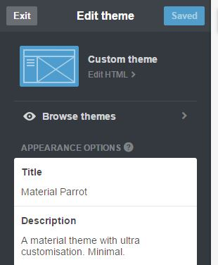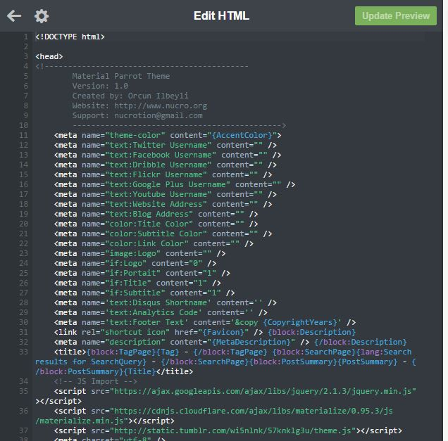

**Theme Settings**

Parrot supports almost all settings tumblr support. All you should do is go to customization and check the theme settings at sidebar. You can switch header items and reshape your header section.

Let’s look the screenshots and look what theme gives you.

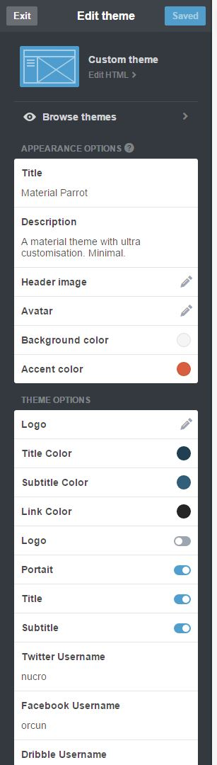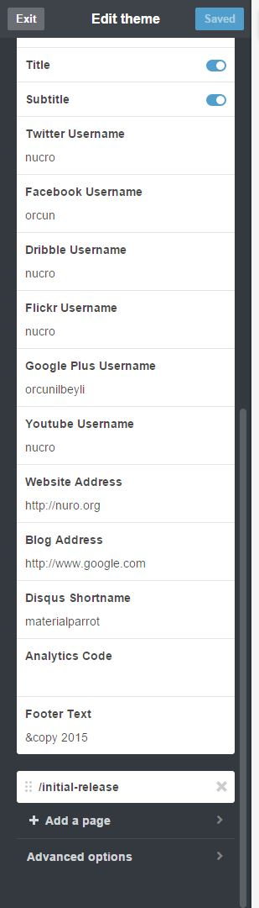

As you can see above, Parrot lets you change many settings about theme. You can even enter your very own CSS. If you want to change the source code of CSS and JS files, head into the zip file you have downloaded. You'll see the according folders.

**FAQ**

* How to enable **Google Analytics**?

Go to theme customization area. At left-sidebar you will see a text box that say Analytics Box. Just paste the tracking code and you are good to go.

* How to enable **Disqus** comment system?

Go to theme customization area. At left-sidebar you will see a text box that say disqus shortname. Just write your disqus shortname. Now your blog has comment support.

* Does Parrot has any social widget support?

For now, unfortunately **no**. As planned, Parrot does not have social integration. But it will have in future updates. So stay updated every time.

* Parrot is responsive. How to enable it?

Go to advanced settings in customization sidebar and disable default tumblr mobile page interface.

* How can I get support when needed?

Use this document to get support. If further support needed, you can contact me via email. I’ll respond every support email in 24 hours.

* Is there any info about upcoming updates for Parrot theme?

Yeah you can find this info from Parrot’s official blog page. And there will be a changelog at themeforest when theme updated.